LINUX COMMAND -2

1. nano: used to create file
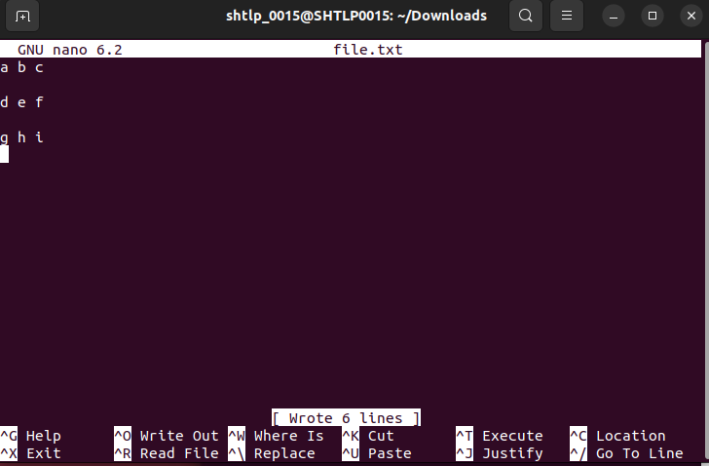
.
2. top: Monitor System process in real time and display current memory usage
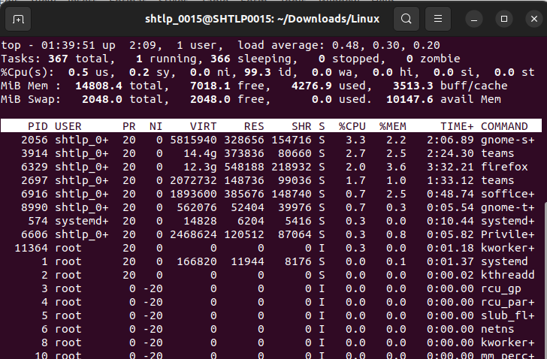
.

3. chmod:(Change File Permission) This command changes the permission of file or directories .
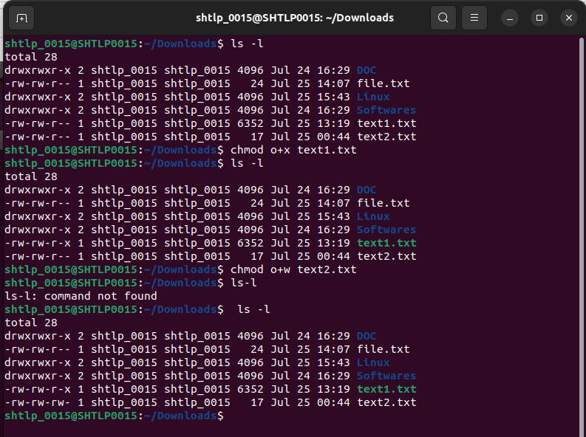
Changing read , write, execute permision of file using chmod:
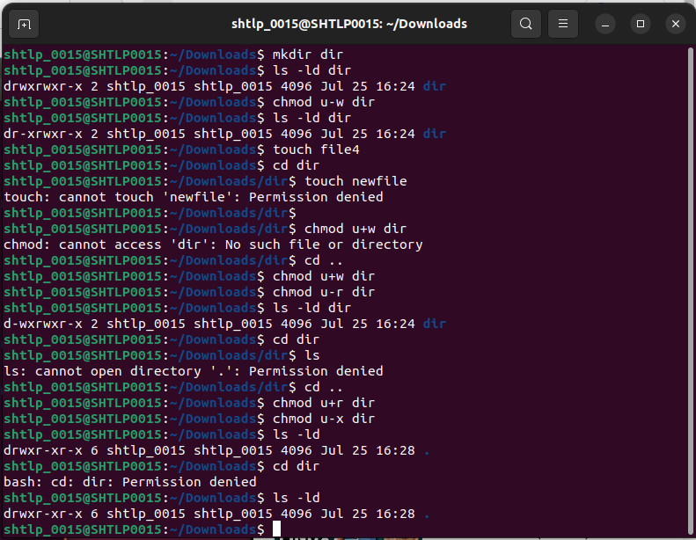
.

Octal and Numerical permission
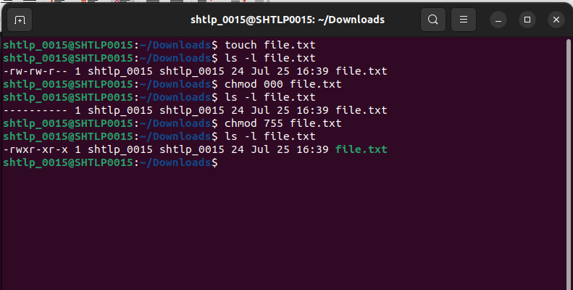
.

4. Introduction to bash scripting
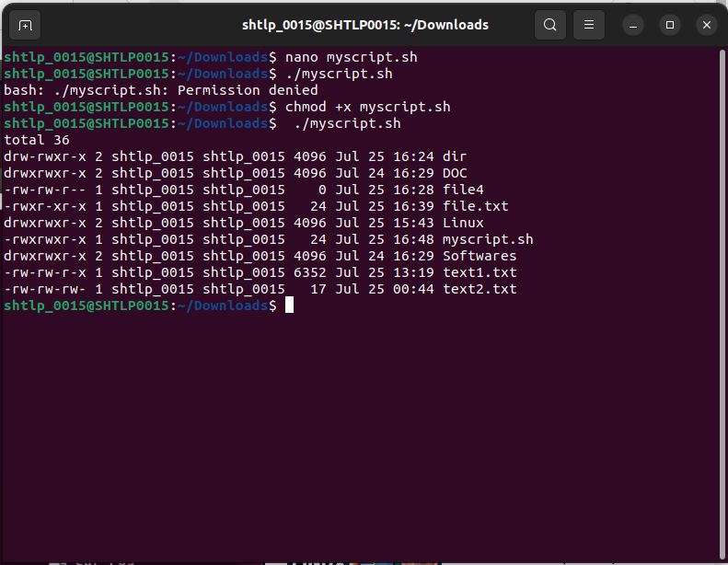
.

BASH : bash script is a file containing a sequence of commands that are executed by the bash program line by line.
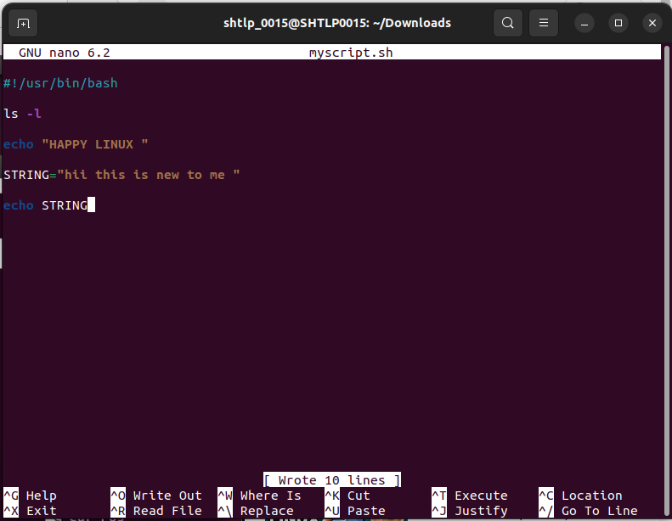
.

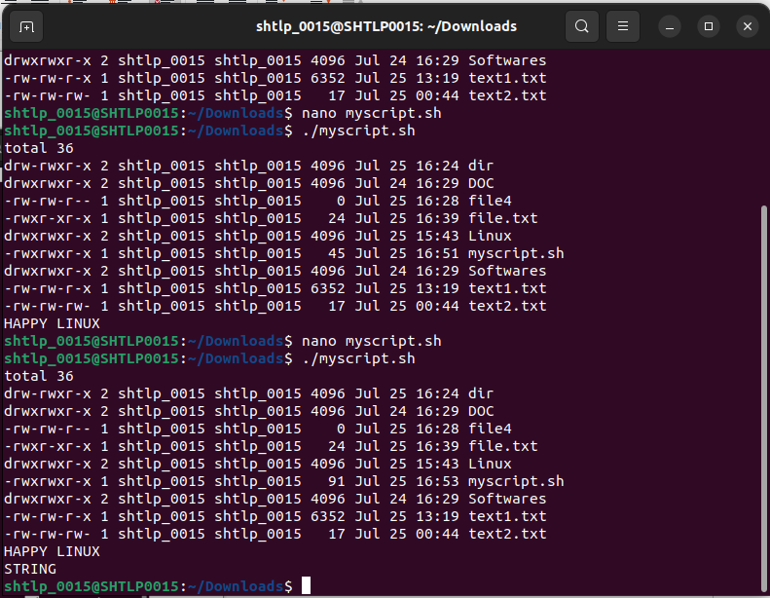
.
5. which: returns the the location or file path of command
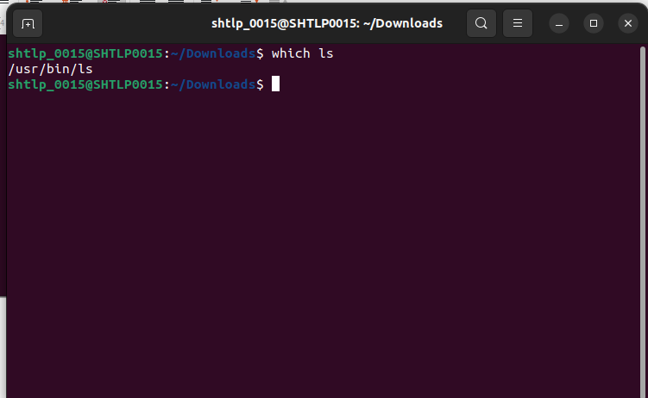

whatis: displays short description about given command
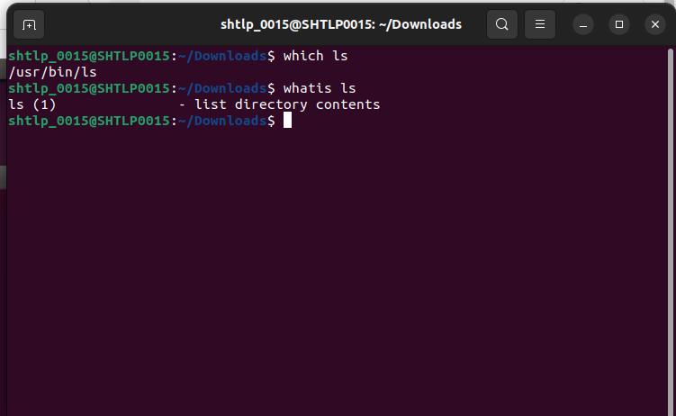
.
7.userdel command (Removing Users) :Adds a new user account to a system.
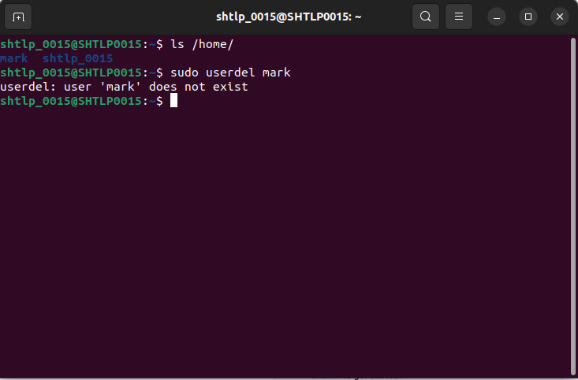
.

8. Basic Group Management (groups, groupadd, groupdel)
group: displays groups to which current user is connected to
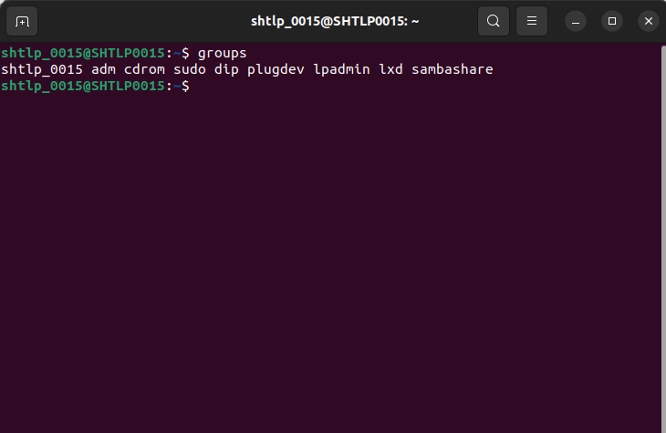
.
groupadd: add a new group
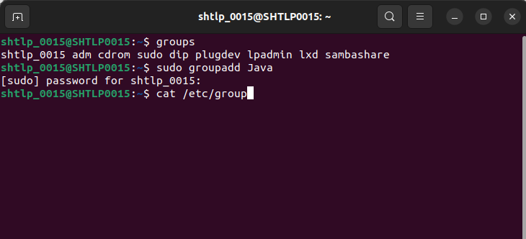

groupdel: delete the existing group
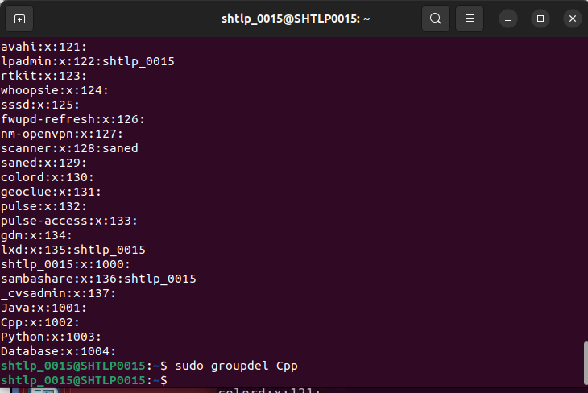
9.bashrc File bashrc file is a configuration file for the Bash shell.
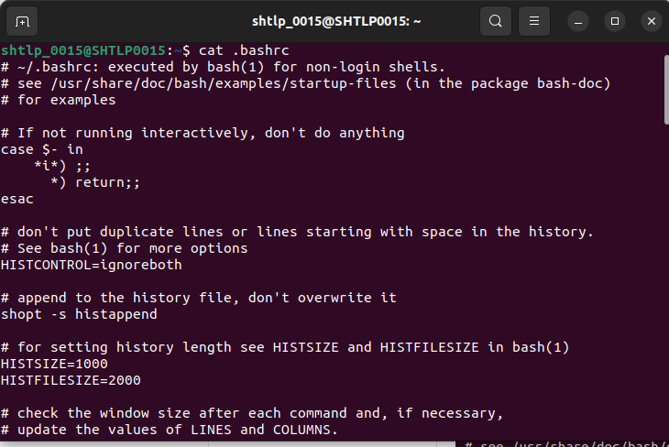

10. Viewing Resources (du , df, free command)

du: Shows the disk usage of file and directories
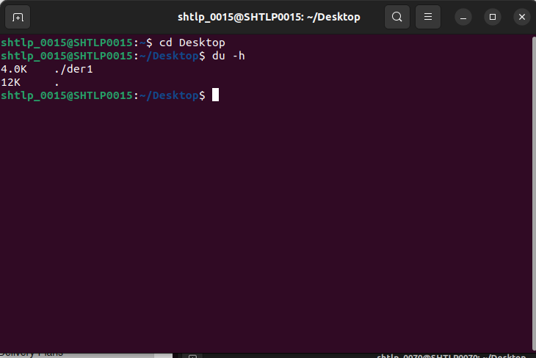
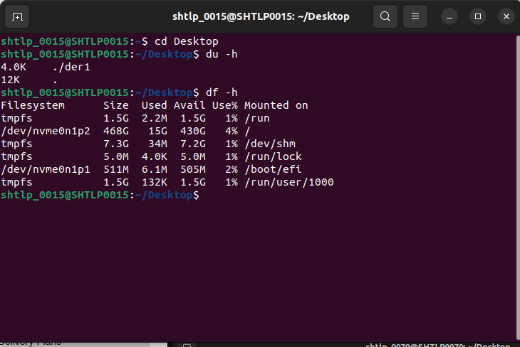
.
df: Displays information about available disk space on filesystem

free : Shows the amount of free and used system memory
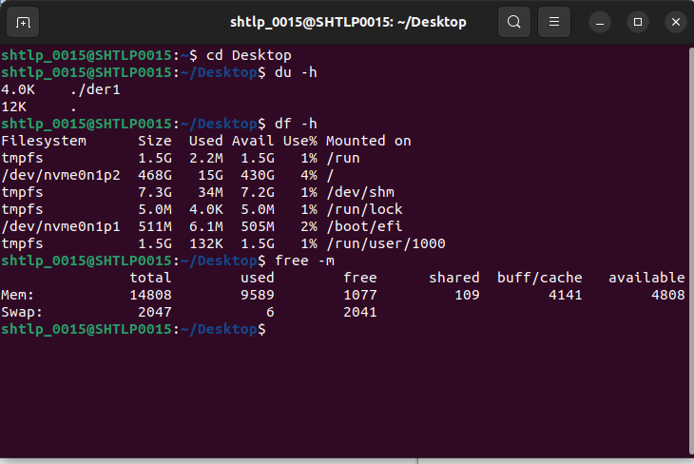
11. watch command : Periodically repeats a command to monitors changes over time
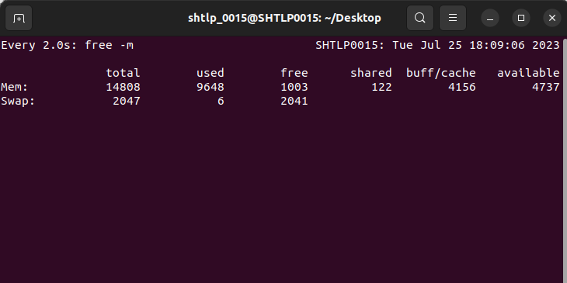

12. Head and Tail Commands
The head command will output the first part of the file, while the tail command will print the last part of the file.
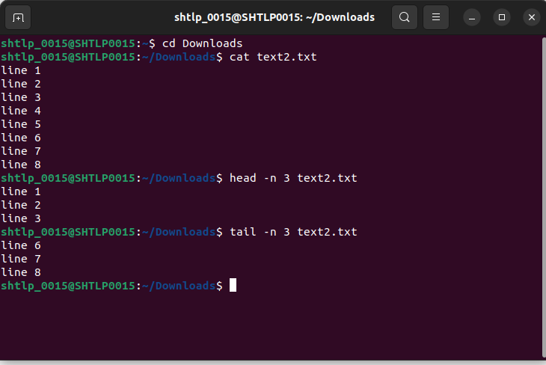
.
13. find command used to find files and directories and perform subsequent operations on them.
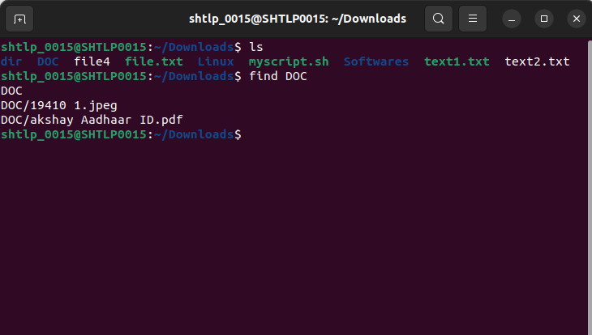

14. wc command
wc is a handy utility to count words, lines, or bytes of the provided input, either a list of files or standard input.
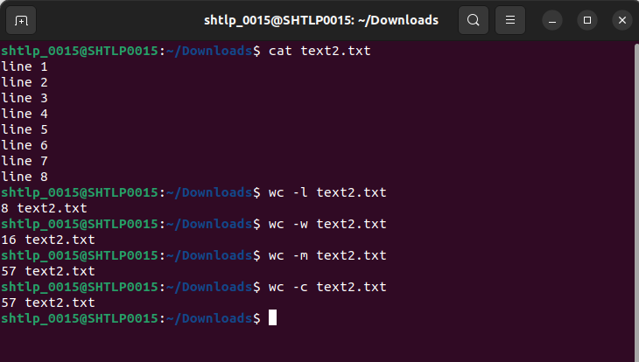

14. cal command :Print a calender for specified command
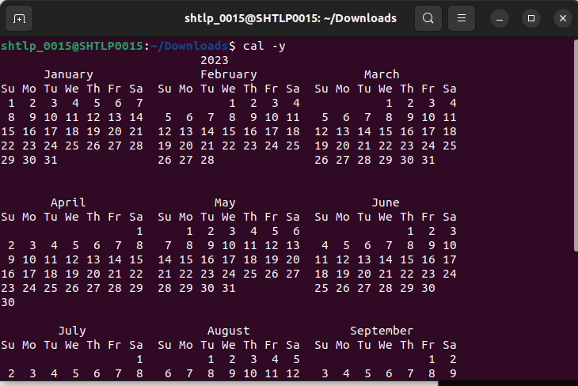
15. date command : displays todays date
